WEEK 6 – GIT – CI/CD
Hands - on – 5 – Git push and git pull

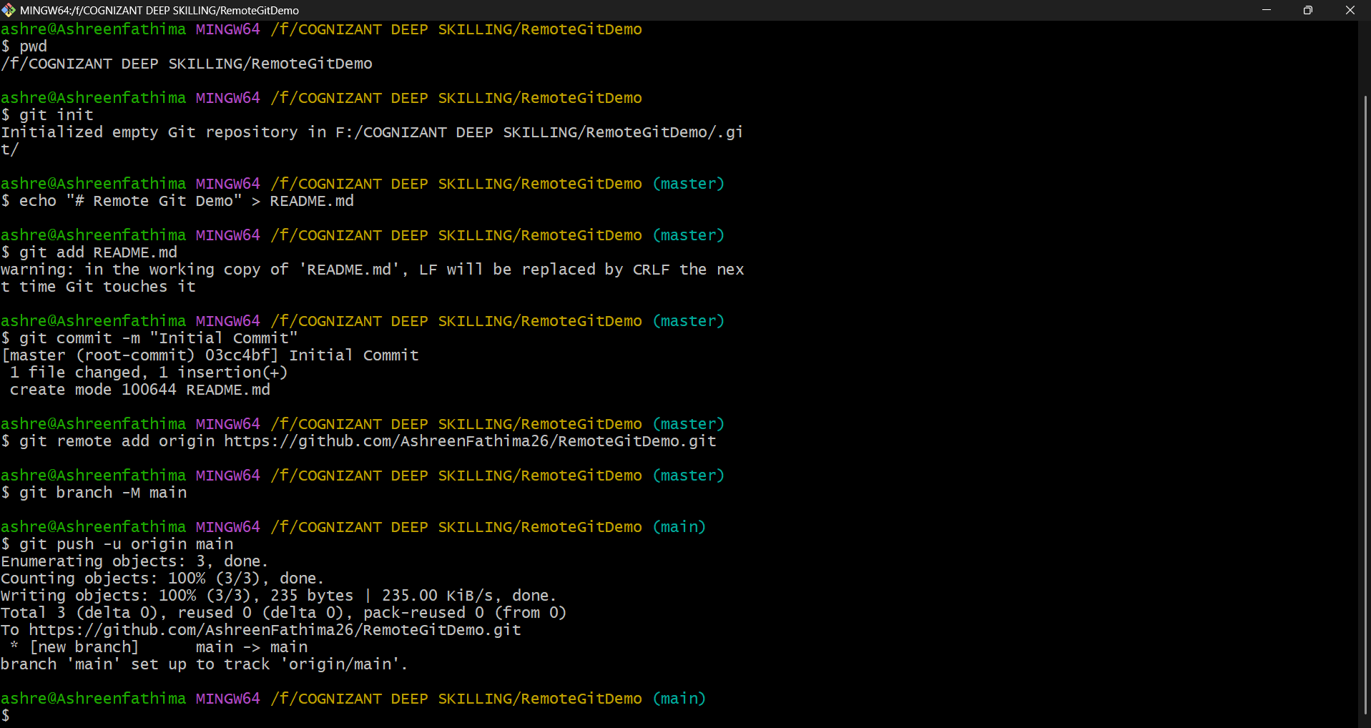
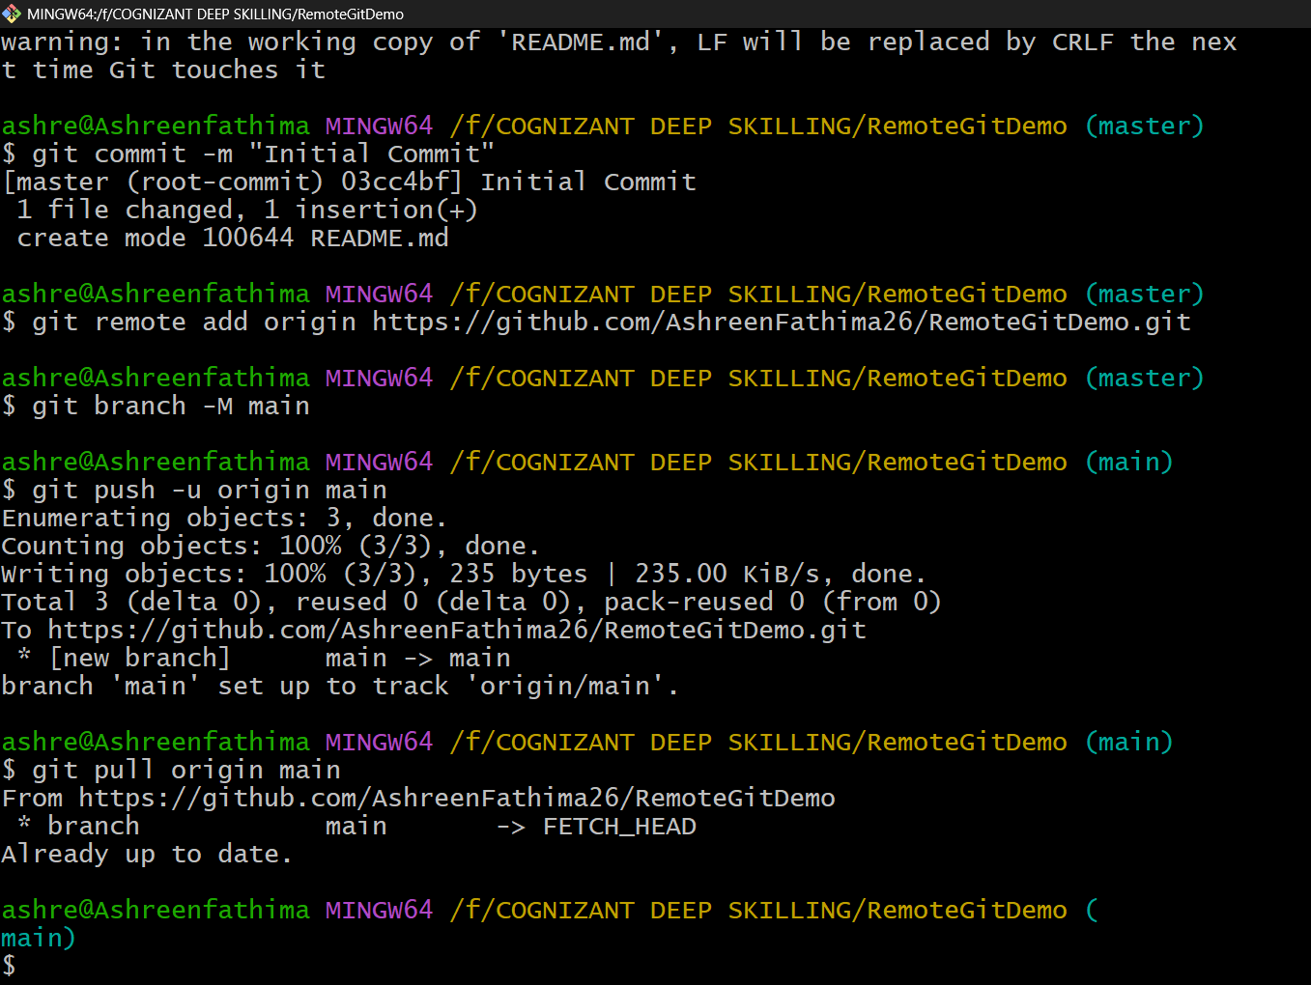

Objective:
To demonstrate Git remote repository operations by pushing a local repository to GitHub and pulling the latest changes from the remote repository.
Commands Used
Step | Command
Initialize Repository | git init
Create README File | echo "# Remote Git Demo" > README.md
Stage File | git add README.md
Commit Changes | git commit -m "Initial Commit"
Add Remote Repository | git remote add origin https://github.com/AshreenFathima26/RemoteGitDemo.git
Rename Branch | git branch -M main
Push to GitHub | git push -u origin main
Pull Latest Changes | git pull origin main

Result:
Successfully created a local Git repository, connected it to a remote GitHub repository, pushed the local repository using Git Push, and synchronized it with the remote repository using Git Pull.
